Supplementary Information

Supplementary Table S1: List of the genes used for the filtering by using ES in our cohort.

ADAMTS10 (MIM 608990), ADAMTS17 (MIM 607511), ADAMTS18 (MIM 607512), ALDH1A3 (MIM 600463), ALDH18A1 (MIM 138250), ANTXR1 (MIM 606410), ASB10 (MIM 615054), ATOH7 (MIM 609875), B3GLCT (MIM 610308), BCOR (MIM 300485), BEST1 (MIM 607854), BMP4 (MIM 112262), CHRDL1 (MIM 300350), CHST6 (MIM 605294), COL18A1 (MIM 120328), COL2A1 (MIM 120140), COL4A1 (MIM 120130), COL8A2 (MIM 120252), CPAMD8 (MIM 608841), CREBBP (MIM 600140), CYP1B1 (MIM 601771), DCN (MIM 125255), DDX58 (MIM 609631), ELP4 (MIM 606985), EYA1 (MIM 601653), FBN1 (MIM 134797), FLNA (MIM 300017), FOXC1 (MIM 601090), FOXE3 (MIM 601094), FOXL2 (MIM 605597), GDF6 (MIM 601147), GJA1 (MIM 121014), HCCS (MIM 300056), IFIH1 (MIM 606951), JAG1 (MIM 601920), KERA (MIM 603288), KRT12 (MIM 601687), KRT3 (MIM 148043), LAMB2 (MIM 150325), LMX1B (MIM 602575), LTBP2 (MIM 602091), MAB21L2 (MIM 604357), MAF (MIM 177075), MFRP (MIM 606227), MYOC (MIM 601652), NOTCH2 (MIM 600275), NTF4 (MIM 162662), OPA1 (MIM 605290), OPA3 (MIM 606580), OPTN (MIM 602432), OTX2 (MIM 600037), OVOL2 (MIM 616441), PAX2 (MIM 167409), PAX3 (MIM 606597), PAX6 (MIM 607108), PEX2 (MIM 170993), PIKFYVE (MIM 609414), PIK3R1 (MIM 269880), PITX2 (MIM 601542), PITX3 (MIM 602669), POMT1 (MIM 607423), PRDM5 (MIM 614161), PRSS56 (MIM 613858), PXDN (MIM 605158), RAB18 (MIM 602207), RAB3GAP1 (MIM 602536), RAB3GAP2 (MIM 609275), RARB (MIM 180220), RAX (MIM 601881), SBF2 (MIM 607697), SEC23A (MIM 610511), SH3PXD2B (MIM 613293), SHH (MIM 600725), SIX3 (MIM 603714), SIX6 (MIM 606326), SLC16A12 (MIM 611910), SLC38A8 (MIM 615585), SLC4A11 (MIM 610206), SLC4A4 (MIM 603345), SOX2 (MIM 184429), STRA6 (MIM 610745), TACSTD2 (MIM 137290), TBC1D20 (MIM 611663), TEK (MIM 600221), TGFBI (MIM 601692), TMEM98 (MIM 615949), UBIAD1 (MIM 611632), VCAN (MIM 118661), VSX1 (MIM 605020), VSX2 (MIM 142993), WDR36 (MIM 609669), ZEB1 (MIM 189909)

Supplementary Table S2: Syndromic and isolated subjects in both solved and unsolved probands.

Type of Probands | Syndromic | Isolated | Solve percentage
Solved Probands | 4 (1 oculo-dental-digital syndrome, 2 Axenfeld Rieger syndrome, 1 Peters plus syndrome) | 6 | 40% solved
Unsolved Probands | 3 (3 Axenfeld Rieger syndrome) | 11 | 21.4% solved

Supplementary Table S3: Phenotypic features of the unsolved probands.

Family-individual ID | Sex | Simplex/  Multiplex | Ethnicity | Eye Phenotype | Additional Clinical and Family Characteristics
2-II:1 | M | Sx | Black, non-Hispanic | AR with glaucoma | -
4-II:1 | M | Sx | White, Hispanic | Peters OD, anopthalmia OS | -
7-II:1 | F | Sx | White, non-Hispanic | AR OD, corneal opacity OS | -
9-II:1 | M | Mx | White, Hispanic | AR with glaucoma | Sister had PCG and father had glaucoma
13-II:1 | M | Sx | Black, Hispanic | Aniridia | -
15-II:1 | F | Sx | White, non-Hispanic | PCG | -
16-II:1 | F | Sx | White, Hispanic | corneal dystrophy with suspected glaucoma | -
17:II-1 | F | Sx | White, non-Hispanic | Peters anomaly OU | -
19-II:1 | M | Sx | Black, non-Hispanic | PCG | -
20-II:1 | F | Sx | White, non-Hispanic | PCG | -
21-II:1 | M | Sx | Black, non-Hispanic | PCG | -
22-II:1 | F | Sx | Black, non-Hispanic | PCG | -
23-II:1 | M | Sx | White, Hispanic | PCG | -
24-II:1 | M | Mx | Black, non-Hispanic | Congenital glaucoma | One sibling has glaucoma

M: male, F: female, Sx: simplex, Mx: multiplex, y: years, AR: Axenfeld Rieger anomaly, OD: Right eye, OS: Left eye

Supplementary Table S4: Characteristics of common genes for anterior segment dysgenesis

Gene | OMIM | Phenotype | Inheritance | Reported type of variants
 |  |  |  | Missense | Loss of function | CNVs | splice
CYP1B1 | 617315 | Peters anomaly, corneal edema, corneal leucoma | AR | + | + | + | +
FOXC1 | 601631 | Goniodysgenesis, Rieger anomaly, Peters anomaly, corectopia | AD | + | + | + | +
FOXE3 | 610256 | Microphthalmia, sclerocornea, Peters anomaly | AR | + | + | NA | NA
PAX6 | 604229 | Aniridia, Peters anomaly, keratitis, foveal hypoplasia, congenital cataract | AD | + | + | + | +
PITX2 | 137600 | Glaucoma, hypoplastic iris stroma, goniodysgenesis | AD | + | + | + | +
PITX3 | 107250 | Microcornea, synechiae, Peters anomaly | AD | + | + | NA | NA
PXDN | 269400 | Microcornea, iridocorneal dysgenesis, sclerocornea, cataract | AR | + | + | + | +

AD: autosomal dominant; AR: autosomal recessive; Loss of function: nonsense and frameshifts; CNVs: copy number variants

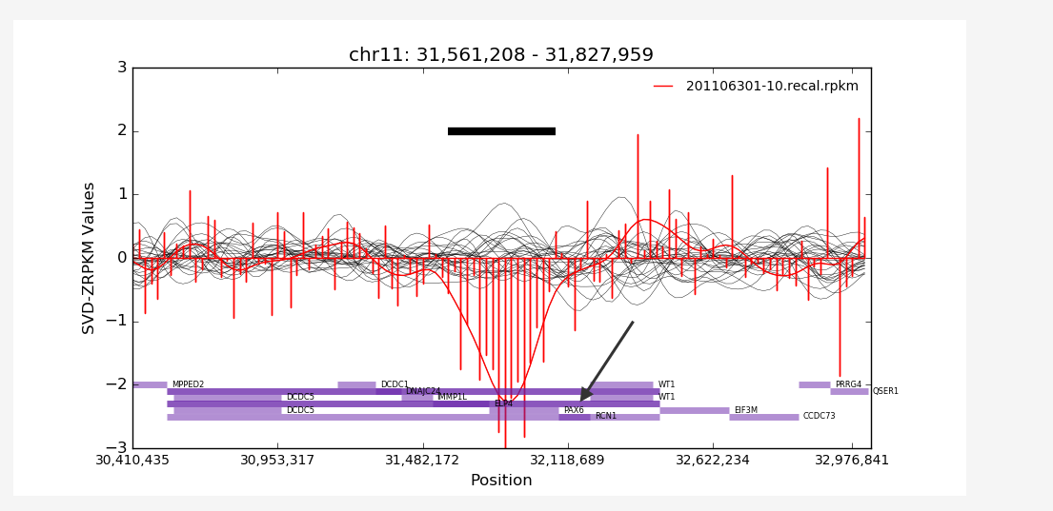

Supplementary Figure S1: Representation of the PAX6 gene deletion by using CoNiFER. Black line shows PAX6 gene region and black arrow shows PAX6. Coordinates are based on hg19.

